# Setup Challenge 2: MailSploit

* In this challenge, a really bad CIA cyber security agent gives you a short python script and forgets his Gmail credentials inside, makes him an easy target.

1. Hiding flag:

Use <http://www.audiocheck.net/audiocheck_spectrotyper.php> to hide your flag inside an audio file spectrogram:

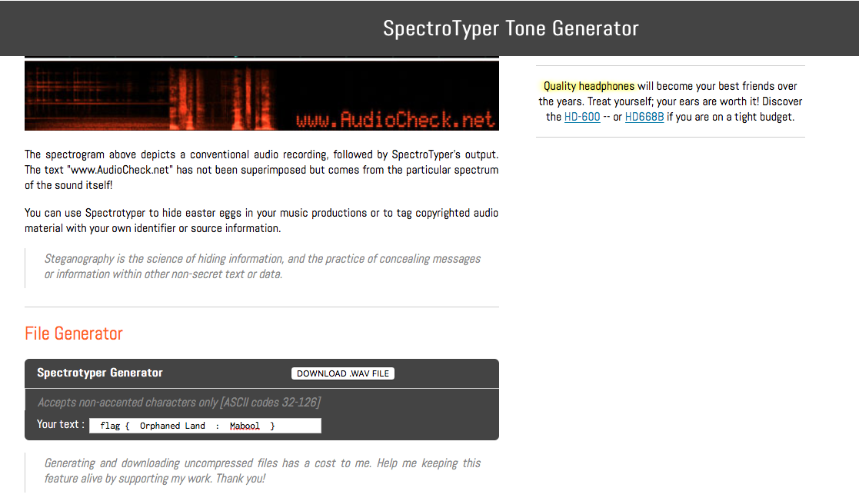

Download the .wav file and save it on your computer

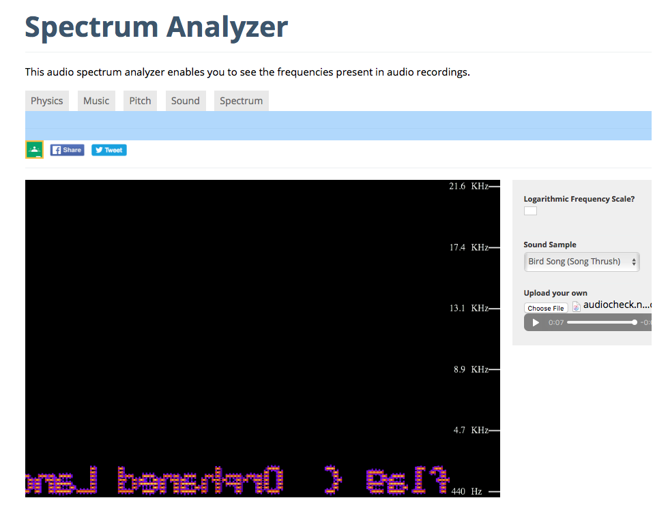Check that worked using: <https://academo.org/demos/spectrum-analyzer/>

1. Reverse the audio file using: <https://www.mp3-reverser.com/en/>

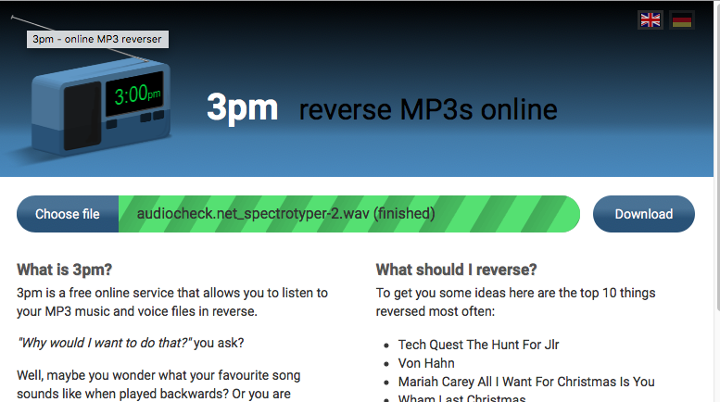

1. Create a new google account:

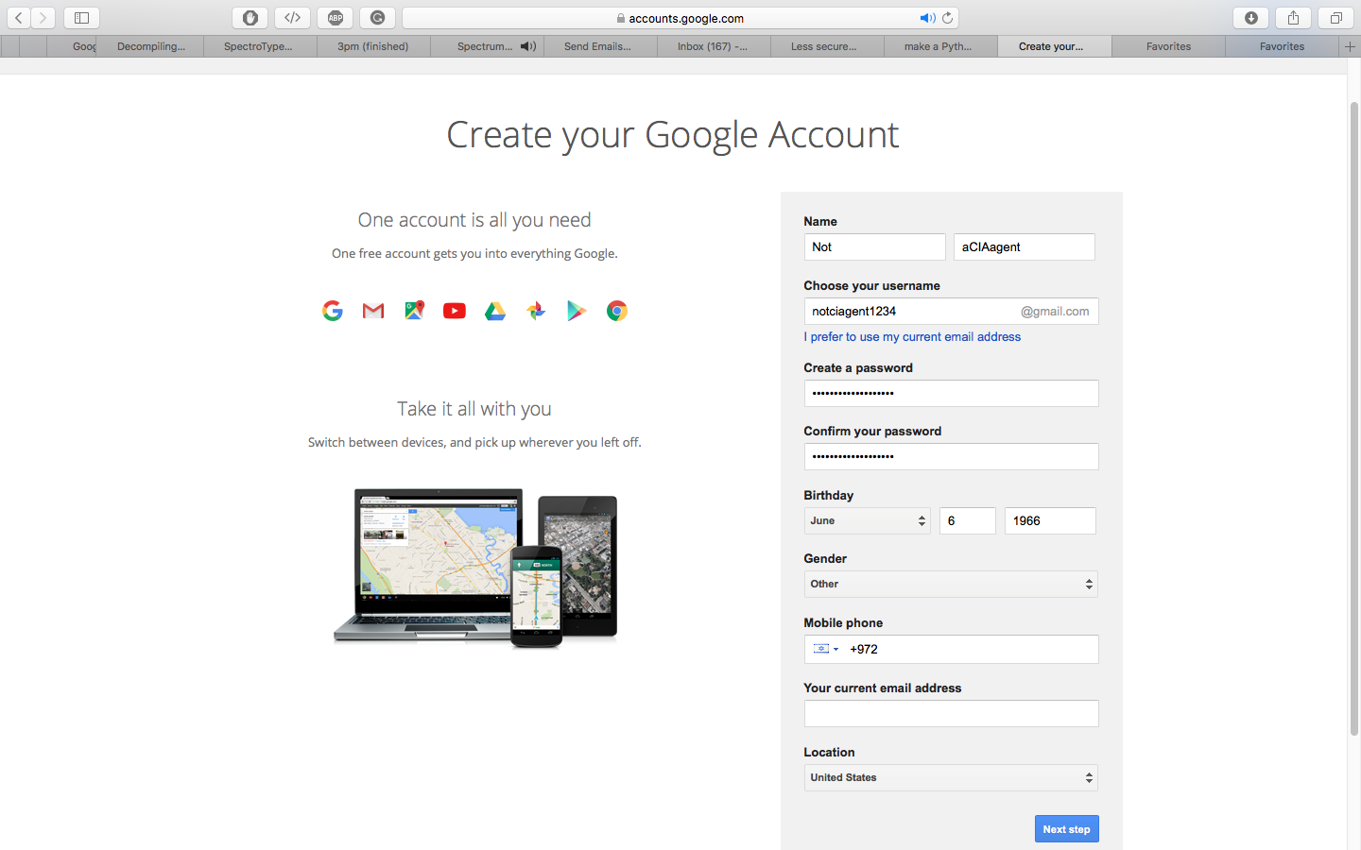

1. 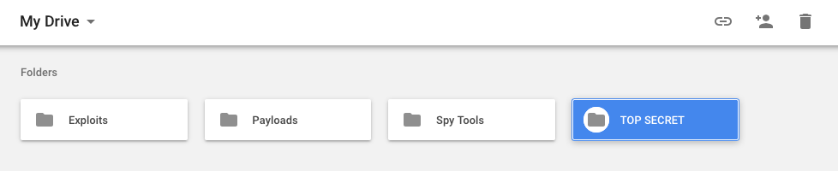Put the audio file in some folder in this account google drive

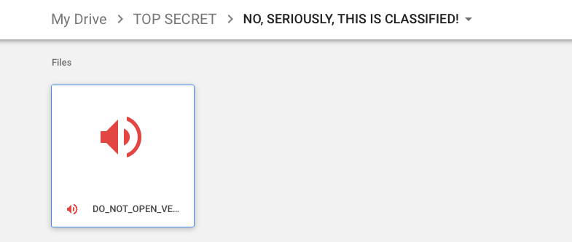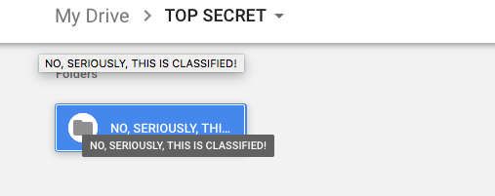

1. Create another folder and call it *Spy Tools* and create a new google document inside it

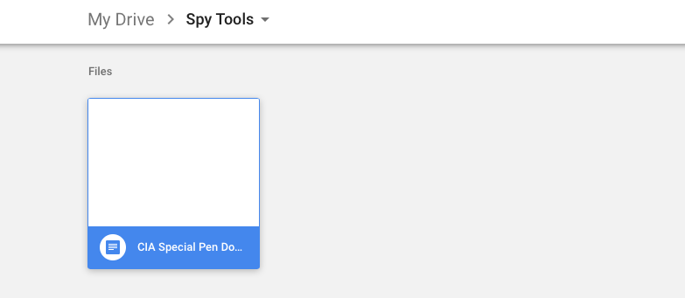

1. Copy the links for Spectrum Analyzer tool and the 3pm audio reversing tool and some more other not related tools, just to make it more authentic, change the links color to white to make them invisible

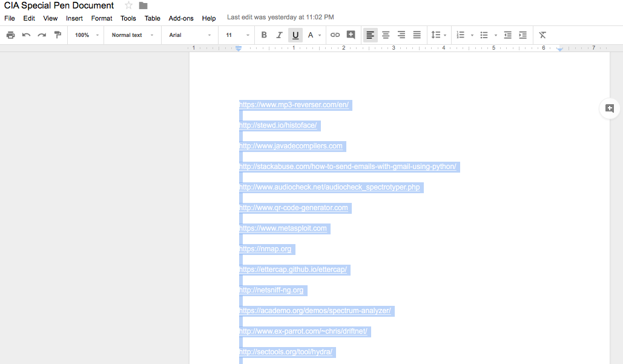

1. Create a python script that sends weird emails that using in the name and the password of the new google account that we just created

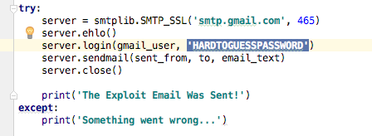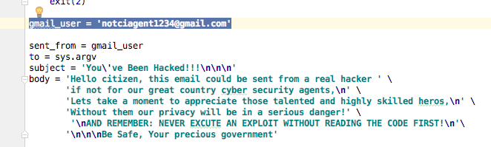

The user gets only that mailsploit.py file and will need to find the Gmail account and password inside it.